|  |  |
| --- | --- |
| **Network Infrastructure**  Diploma in CSF / IT  Year 2 (2022/23) Semester 3 | Week 04 |
| Tutorial |
| DYNAMIC ROUTING | |

**OBJECTIVES**

After completing this session, you should have a better understanding of Dynamic Routing.

**Activity 1** (40 minutes) Dynamic Routing

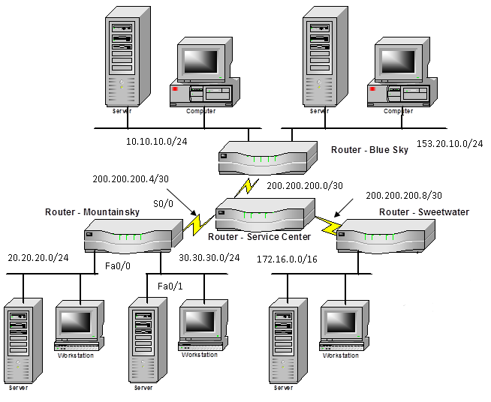



**Figure 1: Typical Corporate Network**

1. Figure 1 shows a typical corporate network with 4 routers. To allow the routers to response dynamically to topology changes, the network administrator decided to use RIP routing protocol. Write down the commands to configure all the Sweetwater router’s interfaces with their respective IP addresses. All Sweetwater router’s interfaces are assigned the first usable address of their respective subnets.

|  |
| --- |
| *Sweetwater(config)# interface s0/0*  *Sweetwater(config-if)# ip address 200.200.200.9 255.255.255.252*  *Sweetwater(config-if)# exit*  *Sweetwater(config)# interface fa0/0*  *Sweetwater(config-if)# ip address 172.168.0.1 255.255.0.0* |
|  |

1. Write down the commands to configure the Sweetwater router to dynamically update its routing table using RIP.

|  |
| --- |
| *Sweetwater(config)# router rip*  *Sweetwater(config)# network 200.200.200.8*  *Sweetwater(config)# network 172.168.0.0* |

1. Describe the term “update interval” used in routing protocol. What is the value of update interval for RIP?

|  |
| --- |
| “Update interval” is the time interval between each update the router sends to its neighbors.  The value of update interval for RIP is 30 seconds. |

1. Describe the term “metric” used by routing protocols. What is the metric used by RIP?

|  |
| --- |
| Metric in routing protocols is used to rank the possible paths from most preferred to least preferred based on certain metrics (conditions) such as speed, reliability, number of hops and delay. RIP uses hop count as its metric. |

1. All the routers in Figure 1 had been configured with RIP routing protocol. All the routing updates had been successful, and all their routing tables are accurate and are up to date.

Fill up the routing table for router Sweetwater in Table 1 below.

|  |  |  |  |
| --- | --- | --- | --- |
| Destination Network | Interface | Metric | Next Hop Address |
| 172.16.0.0 | Serial | Hops(0) | Direct |
| 200.200.200.8 | Fast Ethernet | Hops(0) | Direct |
| 200.200.200.4 | Serial | Hops(1) | Service Center |
| 200.200.200.0 | Serial | Hops(1) | Service Center |
| 20.20.20.0 | Fast Ethernet | Hops(2) | Mountain Sky |
| 30.30.30.0 | Fast Ethernet | Hops(2) | Mountain Sky |
| 10.10.10.0 | Fast Ethernet | Hops(2) | Blue Sky |
| 153.20.10.0 | Fast Ethernet | Hops(2) | Blue Sky |

Table 1

1. Redesign the network so that there is no single point of failure using minimal additional links.

Answer:

Add an additional link between Service Center and all routers it is connected to. A total of 3 links will be added. As all routers connect to Service Center and rely on it to send packets to other routers, any time a link between one of the routers and service center fail, the network will fail hence a backup link is needed although it will not be active until one of the links fail.